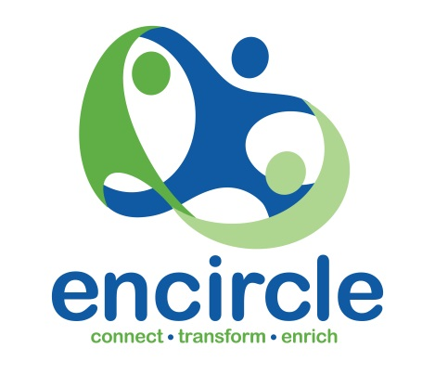

Volunteer Position Description

Mission Statement: “Strengthening individuals and families to take informed control of their lives and together enriching our communities.”

Position Title: | Committee Member (Advisor), Governance and Nominations (GAN) Committee of Encircle Ltd. Board of Management.
Type of Position: | Advisor (Volunteer).
Purpose of the Role: | To actively participate in and provide specialist advice to Governance and Nominations Committee of the Encircle Ltd. Board of Management.

Organizational Environment
Encircle Ltd. is a not for profit community owned and operated organisation for individuals and families in the greater north Brisbane area. Encircle responds to personal and community needs within a safe and welcoming environment through the provision a flexible range of activities, supports and information.
Encircle operates in accordance with its Mission Statement. All staff and volunteers are bound by privacy and confidentiality requirements and the Encircle Ltd. Code of Conduct.

The Governance and Nominations Committee is responsible for developing policy and overseeing the processes that guide the overall Governance of Encircle Ltd.

This committee also carries responsibility for ensuring Encircle Ltd. has an effective and professional Board of Directors and a Chief Executive Officer (CEO) with appropriate delegations, and a skilled and supported team of staff and volunteers to achieve the vision of the Board in accordance with Encircle's mission, Strategic Plan, operating principles, ethical obligations, and relevant legislation.
The Governance and Nominations Committee will develop, review and monitor policy and related documents in its area of responsibility. The review will be performed annually or more often, as
appropriate and will seek input and feedback from staff and volunteers, as appropriate.

This role contributes to the good governance of Encircle Ltd. through its participation in the Governance and Nominations Committee. As a committee member, you will have the opportunity to contribute to the development of policy options which guide the organisation and steer it through the many challenges it faces so that Encircle Ltd. can deliver on its client outcomes.

Responsibilities and Duties
  - Work constructively on the GAN Committee with Board members and the Chief Executive Officer (CEO) to provide good governance.
  - Participate in the development of strategies, policy and procedures for the ongoing development of the organisation
  - Attend and actively participate in committee meetings and Board of Management meetings where appropriate.
  - Recognise and declare any conflicts of interest
  - Act in the best interests of Encircle Ltd.

Related Documents
  - Constitution of Encircle Ltd.
  - Code of Conduct
  - Board Committee Terms of Reference
  - Encircle Ltd.Strategic Plan
  - Board Operational Plan
  - Board Charter
  - Board Orientation Kit
  - Position descriptions for:
    - Chairperson
    - Vice-Chairperson
    - Secretary
    - Treasurer
    - Board Committee member
    - Position Description - Committee Member (Advisor) of Business Development (BDC) Committee of Encircle Ltd. Board of Management
    - Position Description - Committee Member (Advisor) of Governance and Nominiations (GAN) Committee of Encircle Ltd. Board of Management

Adopted by: Board
Date Adopted:
Date of Interim Revision:
Date for Review:

